Arsaw/Arstow AB Panel View Plus HMI USB Backup Instructions

Open HMI Enclosure/CC and insert your USB drive in the USB port.
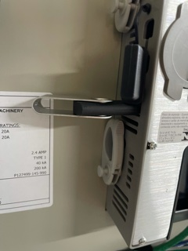
Login to HMI, Press Login and enter 1234
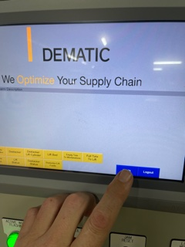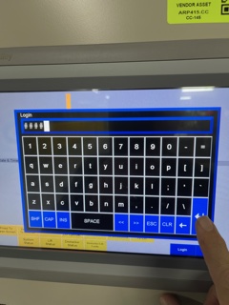

In the lower right by Login you will see Configuration Mode, Select that.
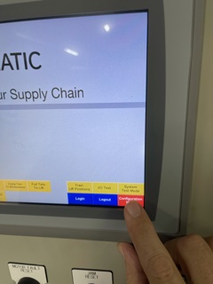

Select Terminal settings
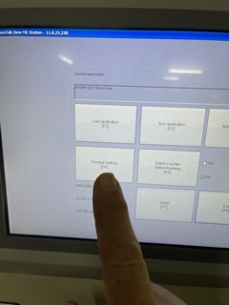

Press Down Arrow to scroll highlight File Management, Press Enter

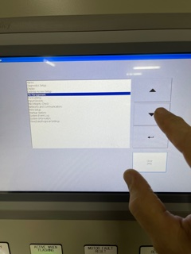

Highlight ->Copy files, Press the Enter Arrow
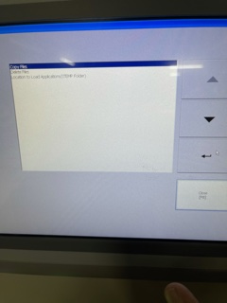
Highlight Copy applications, Press Enter Arrow
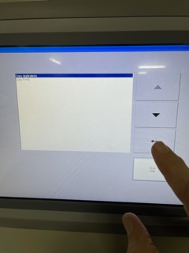

Source = Internal Storage (Select Radial)

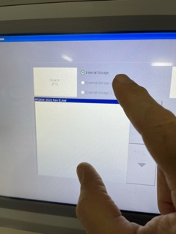

Then Press Destination.
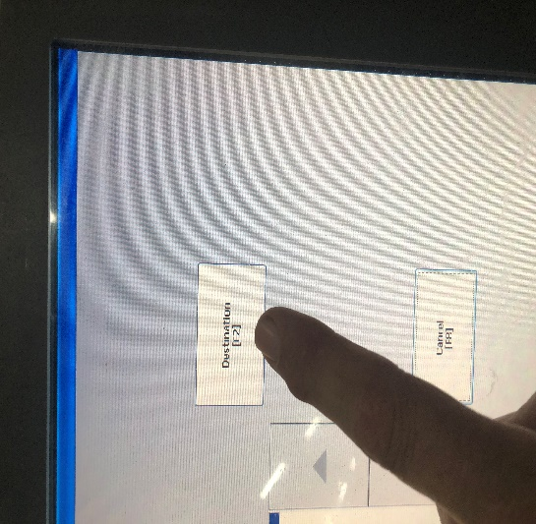
Destination = Press radial External Storage 2, this is the port where your USB drive is plugged in.
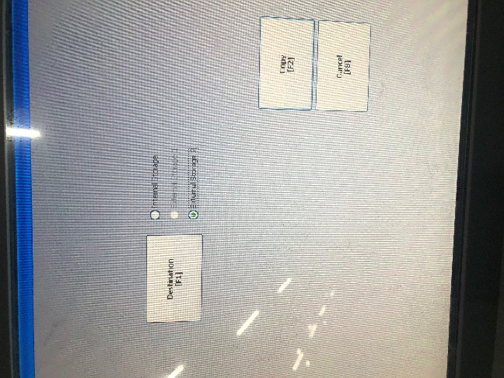

Press Copy
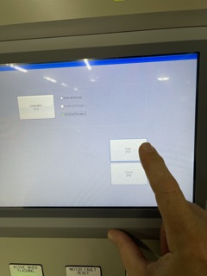

Keep pressing Cancel to back out to main option screen
Press RUN APPLICATION
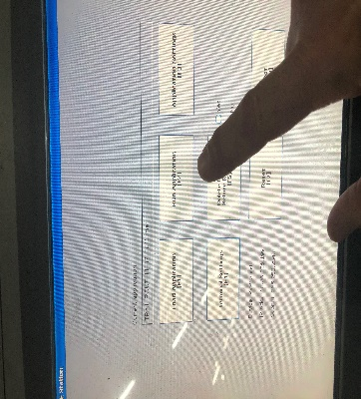
Take out your USB Stick and plug into your laptop and verify the .MER file is in Rockwell Software\RSViewME\->Runtime folder
Copy the .MER file to the share drive correct folder.

